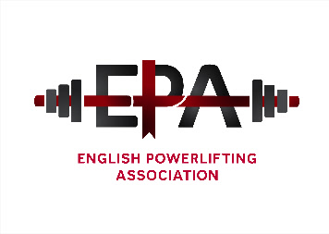

Notice is hereby given of the English Powerlifting Association 2015 Annual General Meeting. The
meeting will be held at in room H7, Gate 4, Moulton College, Pitsford Road, Moulton
Northampton NN3 7QL on Sunday the 10th January 2016 commencing at 11.00am.

Proposed agenda;
1. Members present
2. Apologies
3. Acceptance of minutes from 2011 AGM (1/2/2015)
4. Officer reports
5. Election of officers, currently-

Position | Officer
President | Harry Turner*
Chairman | Richard Parker
General Secretary | Kevin Jane
Treasurer | Fred Sterry
Assistant treasurer | Doreen Dowsett
Sponsorship secretary | Fred McKenzie
Championship secretary | Kevin Jane
Selection secretary | Fred Sterry
Merchandising officer | Kevin Jane
Records Officer | Ian Finch
Web Master | Matthew Parker
Director for England | Kevin Jane

Divisional representatives:
DIVISION | REPRESENTATIVE
East Midlands | Peter Weiss
North Midlands | Fred Sterry
South Midlands | Dean Bowring
West Midlands | Jaswinder Singh
Greater London | Anna Macnab
North West | Bryn Evans
South East | John Halfacre
South West | Kevin Green
Yorkshire North East | Fred McKenzie

7. Championship dates
8. Council meeting dates
9. Notices of Motion
10. A.O.B.
- PLEASE NOTE – Only current members of the Great Britain Powerlifting Federation are entitled to attend and vote at this meeting. All Officer’s reports should be presented in a written format and passed to the General secretary no later than the 12th December 2015. Any notices of motion for alterations to the constitution should be made to the General Secretary no later than the 29th December 2015.
General Secretary – Kevin Jane 6, The Nurseries, Moulton, Northampton NN3 7SA. Tel 01604 491194 Mob. 07887903104 e-mail kevin@kjane,fsbusiness.co.uk

