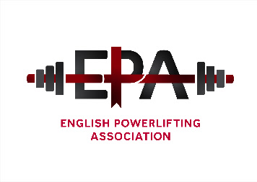

The English Powerlifting Association - Annual General Meeting for 2020
The meeting will be held via Skype chat room on Saturday 30th January 2021 commencing at 10.30am. (kevinjane 51@btinternet.com SKYPE NAME live:.cid.97010e7af5194a1
- No notices of motion have been received and no nominations for officer positions although there are vacancies to be filled.
AGENDA;
Members present
- Apologies
- Acceptance of previous AGM minutes (1/2/2020).
- Officer reports Written only)
- Election of Officers (currently)
Position | Officer
President | Fred McKenzie
Chairman | Richard Parker
General Secretary | Kevin Jane
Treasurer | Vacant
Assistant treasurer | Doreen Dowsett
Sponsorship secretary | Fred McKenzie
Championship secretary | Kevin Jane
Selection secretary | Vacant
Records Officer | Ian Finch
Web Master | Matthew Parker
Director for England | Kevin Jane
Divisional representatives : Currently
DIVISION | REPRESENTATIVE
East Midlands | Peter Weiss
North Midlands | Nathan Turner
South Midlands | Dean Bowring
West Midlands | Jaswinder Singh
Greater London | Joy Nnamani
North West | Bryn Evans
South East | Mick Elender
South West | Emily Greenway
Yorkshire North East | ?
- Championship Dates
- Council meeting dates
- Notices of motion (None received)
- Election for Director of English powerlifting position, currently Kevin Jane
- Any other business

